DSA 0601 - Data handling and visualization
Set 7 - Customer Demographics Analysis

Name : B.Jahnavi
Reg.no:192325043

1.Bar Chart of Customer Ages
library(ggplot2)
customers <- data.frame(
Customer_ID = c(1, 2, 3),
Age = c(28, 35, 42),
Gender = c("Female", "Male", "Female"),
Income = c(50000, 60000, 75000)
)
ggplot(customers, aes(x = factor(Age), y = Age)) +
geom_bar(stat = "identity", fill = "steelblue") +
labs(
title = "Distribution of Customer Ages",
x = "Customer Age",
y = "Age"
) +
theme_minimal()

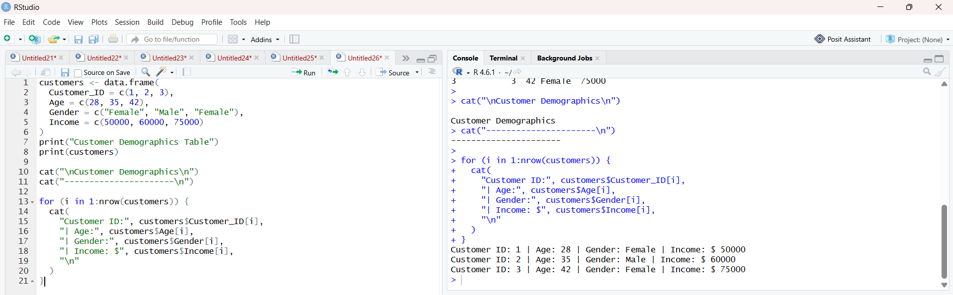

Pie Chart of Gender Distribution
library(ggplot2)
customers <- data.frame(
Customer_ID = c(1, 2, 3),
Age = c(28, 35, 42),
Gender = c("Female", "Male", "Female"),
Income = c(50000, 60000, 75000)
)
gender_count <- as.data.frame(table(customers$Gender))
colnames(gender_count) <- c("Gender", "Count")
ggplot(
gender_count,
aes(x = "", y = Count, fill = Gender)
) +
geom_bar(
stat = "identity",
width = 1
) +
coord_polar("y") +
labs(
title = "Customer Distribution by Gender",
fill = "Gender"
) +
theme_void()

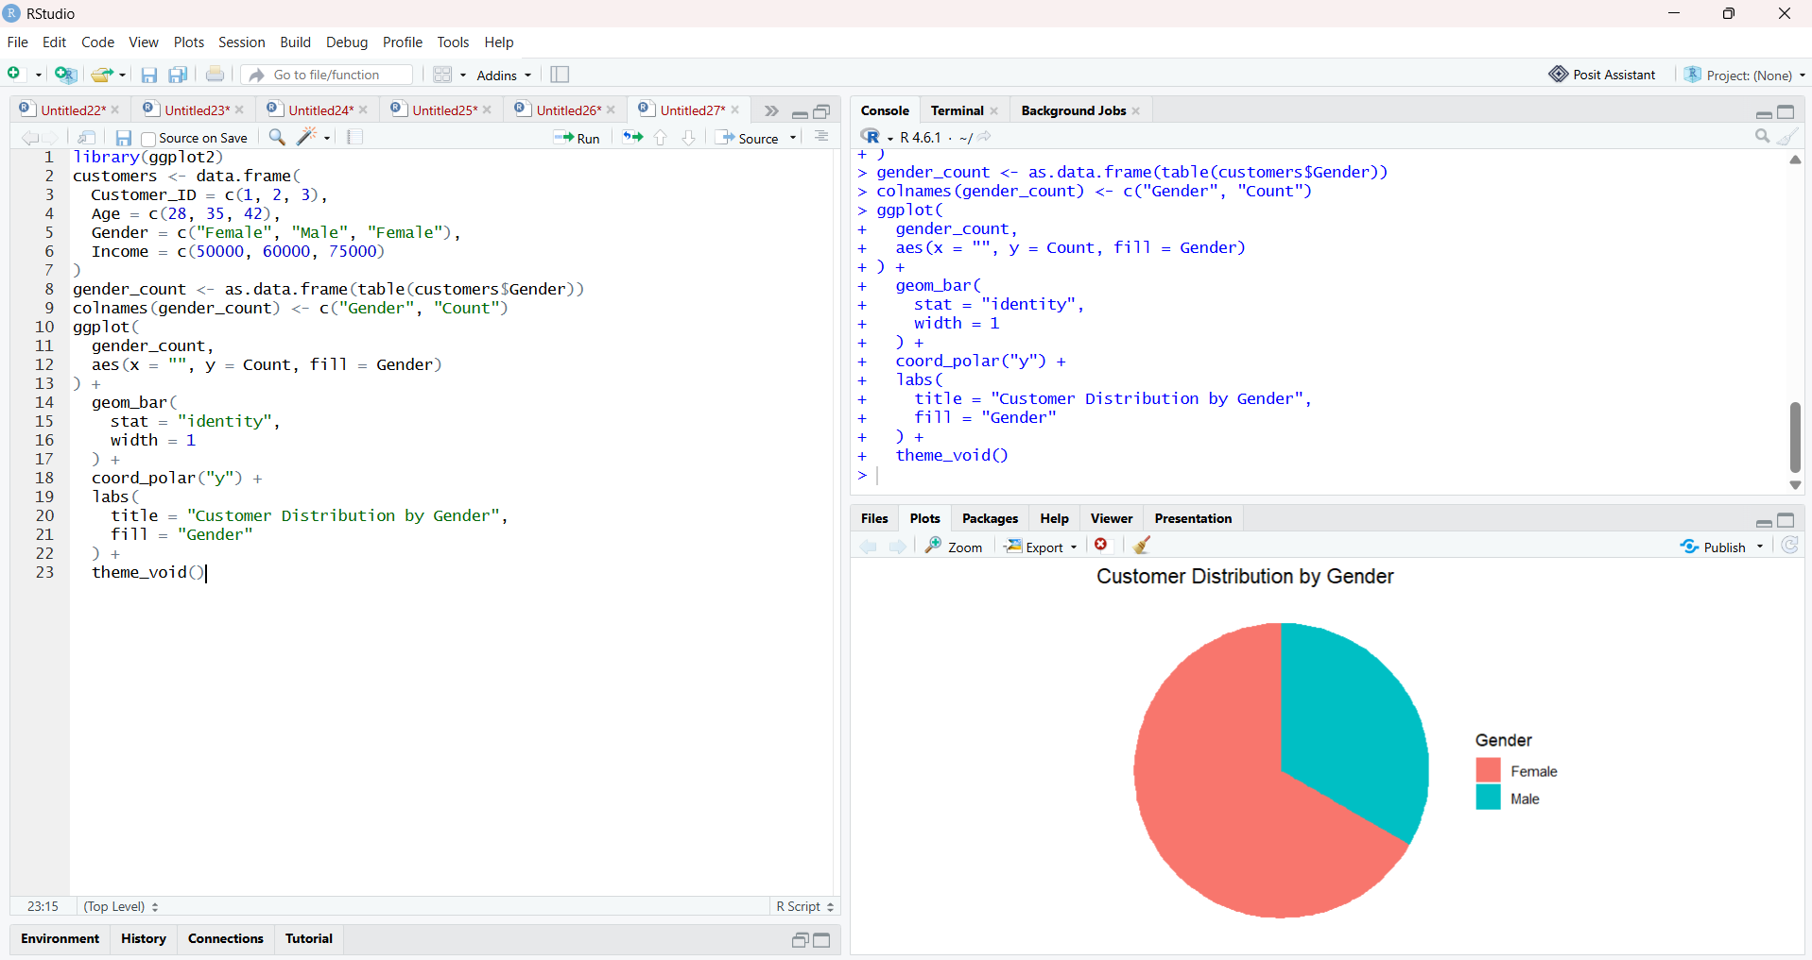

Customer Demographics Table
customers <- data.frame(
Customer_ID = c(1, 2, 3),
Age = c(28, 35, 42),
Gender = c("Female", "Male", "Female"),
Income = c(50000, 60000, 75000)
)
print("Customer Demographics Table")print(customers)

cat("\nCustomer Demographics\n")cat("----------------------\n")
for (i in 1:nrow(customers)) {
cat(
"Customer ID:", customers$Customer_ID[i],
"| Age:", customers$Age[i],
"| Gender:", customers$Gender[i],
"| Income: $", customers$Income[i],
"\n"
)
}

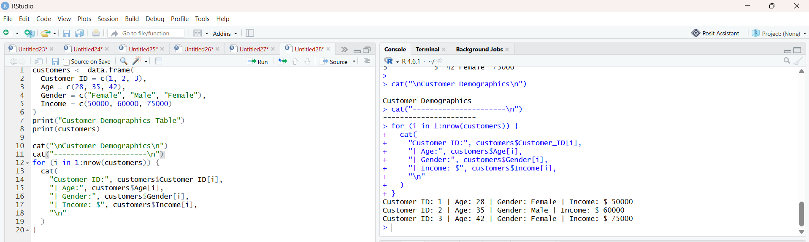

4. Tableau Dashboard
customers <- data.frame(
Customer_ID = c(1, 2, 3),
Age = c(28, 35, 42),
Gender = c("Female", "Male", "Female"),
Income = c(50000, 60000, 75000)
)
write.csv(
customers,
"Customer_Demographics.csv",
row.names = FALSE
)
print("Customer_Demographics.csv created successfully!")

